LAB 7: FUZZING FOR INPUT VALIDATION BUGS
Water Utility Billing System — Lab 7 Verification Report
Student Name: | Tharunyah
SRN: | PES2UG24CS561
Section / Semester: | Section J | 6th Semester
Course / Institution: | Software Engineering: Testing & Agile Practices (SETAP) | PES University

1. Objective & Software Requirements
• Objective: To explore fuzz testing as a dynamic security and quality assurance technique by identifying and fixing bugs in the provided Water Utility Billing input processing module using the Hypothesis property-based testing framework.
• Learning Outcomes:
1. Understand the methodology and purpose of property-based fuzz testing.
2. Formulate automated fuzzing tests using the @given decorator and Hypothesis input strategies.
3. Detect and analyze critical runtime exceptions triggered by malformed delimiters, empty tokens, and null inputs.
4. Apply defensive programming principles to harden the system against malformed and unexpected inputs.
• Environment & Tools: Python 3.12.10, pytest 9.2.0, hypothesis 6.170.15, Git version control.
2. Module Under Test (processor.py)
The module under test simulates data parsing and ingestion routines for a municipal water billing system:
1. sanitize_meter_id(meter_id): Strips whitespace, removes special symbol prefixes (!, @, #, $, %), and returns the uppercase meter identifier.
2. parse_consumption_readings(readings_csv): Splits comma-separated consumption strings into a list of integer sensor readings.
3. format_billing_summary(account_record): Parses colon-delimited records (Name:Usage:Zone) and outputs formatted billing summaries ($2 per unit).
3. Step 2: Executing the Buggy Application
The initial starter script (processor.py) was executed in the Lab 7 directory with standard interactive sample inputs:
• Meter ID: !#MTR@123$ --> Sanitized: MTR123
• Consumption Readings: 10,25,30 --> Parsed Readings: [10, 25, 30]
• Account Record: Alice:50:North --> Billing Summary: Customer Alice billed 100 USD in North
While standard 'happy-path' tests succeed, the starter routines lacked essential defensive guards, making them highly vulnerable to crashes.
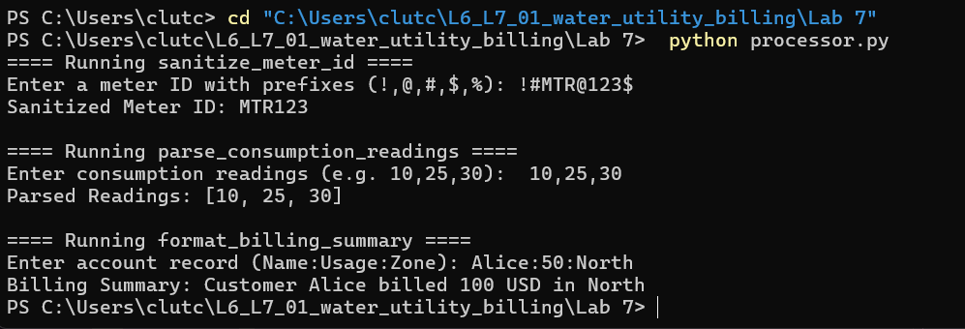
Figure 1: Step 2 — Initial Buggy processor.py Interactive Output
4. Steps 3 & 4: Hypothesis Fuzz Testing & Bug Discovery
Property-based tests were authored in test_processor.py using Hypothesis strategies (st.text() | st.none()). Unlike fixed manual unit tests, Hypothesis generates hundreds of randomized edge-case inputs to actively expose edge cases.
Upon running 'python -m pytest test_processor.py', Hypothesis instantly detected multiple severe failure modes:
• test_sanitize_meter_id_no_crash:
- Failure: s=None triggered AttributeError: 'NoneType' object has no attribute 'strip'.
• test_parse_consumption_readings_safe:
- Failure 1 (Empty String): s='' resulted in ValueError: invalid literal for int() with base 10: ''.
- Failure 2 (Null Input): s=None resulted in AttributeError: 'NoneType' object has no attribute 'split'.
• test_format_billing_summary_safe:
- Failure 1 (Delimiter without units): s=':' resulted in ValueError: invalid literal for int() with base 10: ''.
- Failure 2 (Missing delimiters): s='' resulted in IndexError: list index out of range.
- Failure 3 (Null Input): s=None resulted in AttributeError: 'NoneType' object has no attribute 'split'.
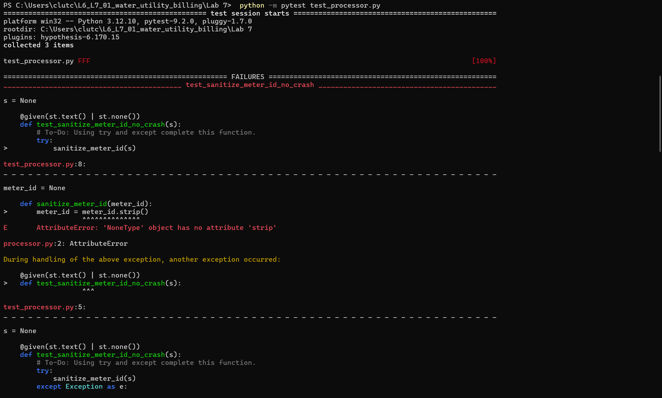
Figure 2: Step 4 — Pytest Output Showing 3 Hypothesis Fuzz Failures
5. Step 5: Hardening and Fixing processor.py
To ensure complete resilience against random, malformed, and boundary inputs, defensive programming patterns were implemented:
1. Strict Type & Null Checking: Verified isinstance(input, str) at entry, returning safe default representations (empty string, empty list, or error message).
2. Robust Token Parsing: Stripped individual tokens, filtered empty strings, and wrapped integer casting in try-except ValueError blocks to silently omit invalid elements.
3. Boundary & Partition Guards: Verified token list lengths prior to indexing (len(parts) >= 3), preventing IndexError and handling corrupted records gracefully.
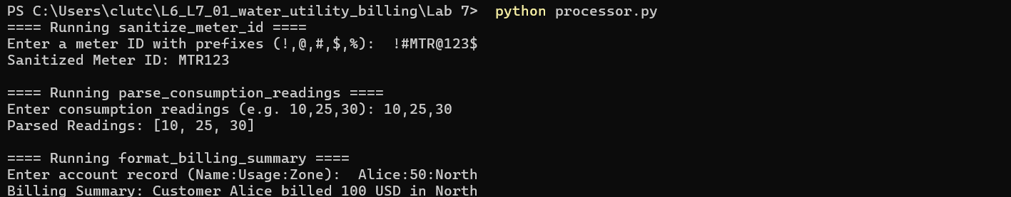
Figure 3: Step 5 — Hardened processor.py Execution Output
6. Step 6: Verification with Re-Executed Fuzz Tests
Running 'python -m pytest test_processor.py' against the hardened processor verified that all 3 property tests passed 100%. Hypothesis generated hundreds of boundary and pseudo-random inputs without triggering a single unhandled exception or crash.
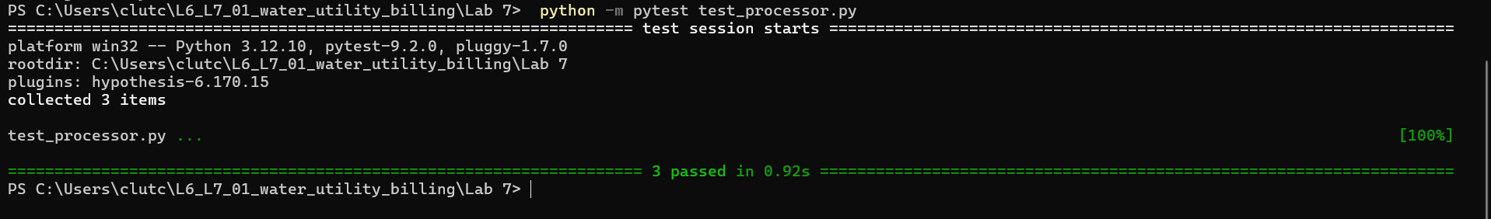
Figure 4: Step 6 — Pytest Output Showing All 3 Tests Passing Successfully
7. Deliverables Summary & Conclusion
• Fixed Application Script: Lab 7/processor.py (defensively hardened against all unexpected inputs)
• Completed Test Suite: Lab 7/test_processor.py (property-based tests using Hypothesis)
• Test Screenshots: Included in this report (Figures 1, 2, 3, 4)
• GitHub Repository: https://github.com/tharunyah/L6_L7_01_water_utility_billing (Lab 7 branch/folder)
Conclusion: Fuzz testing with Hypothesis successfully unmasked 6 critical real-world edge cases that standard manual testing missed. Through defensive programming, the water utility billing processor has been fully hardened into a production-grade, crash-resilient module.

